## Karla Goodwin

CS 340

11/29/2020

## About the Project/Project Title

*This project identifies dogs that are good candidates for search and rescue training. The program will use existing information provided by Grazioso Salvare. The key function is to filter or select the candidates by age and breed as there are certain traits that make dogs more suitable for search and rescue training, like age and breed.*

## Motivation

*Grazioso Salvare’s function is to assist in finding dogs that are good candidates for search and rescue training. They however, do not run or have the data to sift through that shelters do. In part of their work and as part of their mission, 5 shelters have provided the information in their systems so that Grazioso Salvare can continue their work. In doing so, they aide in the rescue of humans and animals, as well as rescuing animals in need. The code is open source to continue to assist in the mission of rescuing animals and people.*

## Getting Started

*To get a local copy up and running, you will need to download the project in a new folder, launch it, and make sure to copy your own data source file into the project.*

## Installation

*You will need access to your shelter data in a file you can import to the source code. You will also need a compatible IDE of your choice to allow you to make changes to the source code if necessary to better suit your project needs.*

## Usage

*The program can be used to search existing files for good candidates for search and rescue. This program will allow users to search options based on what they enter. So for example, a user can search by breed or age if they choose.*

### Code Example

*(base) 1210373_snhu@msnv-snhu3-l004:/usr/local/datasets$ mongoimport --port 51840 --db city --collection inspections ./city_inspections.json*

*2020-11-30T06:07:31.497+0000 connected to: mongodb://localhost:51840/*

*2020-11-30T06:07:33.250+0000 81047 document(s) imported successfully. 0 document(s) failed to import.*

*(base) 1210373_snhu@msnv-snhu3-l004:/usr/local/datasets$ mongoimport --port 51840 --db AAC --collection animals --type=csv--headerline ./aac_shelter_outcomes.csv*

*2020-11-30T06:08:22.613+0000 connected to: mongodb://localhost:51840/*

*2020-11-30T06:08:22.871+0000 10000 document(s) imported successfully. 0 document(s) failed to import.*

***Above is an example on how to load your data into the source code***

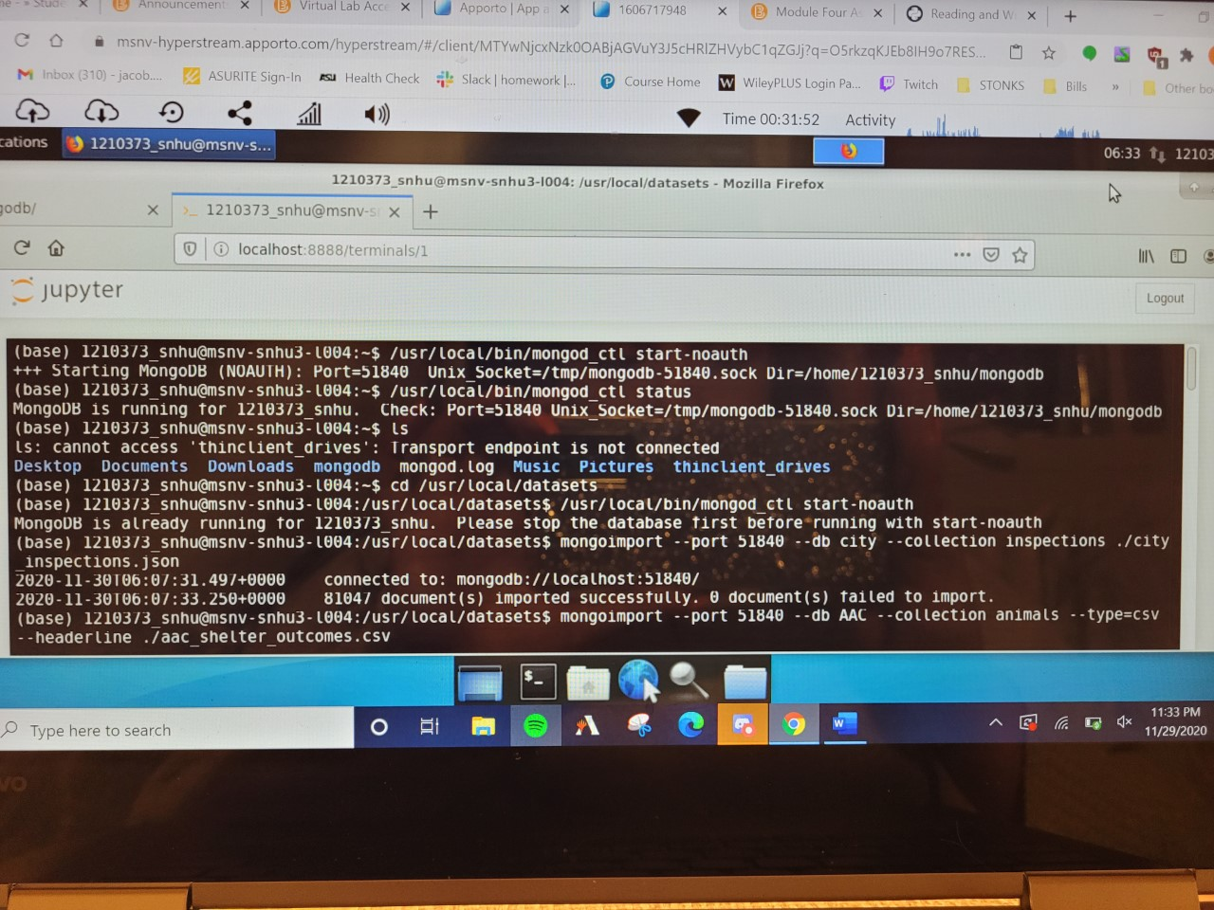

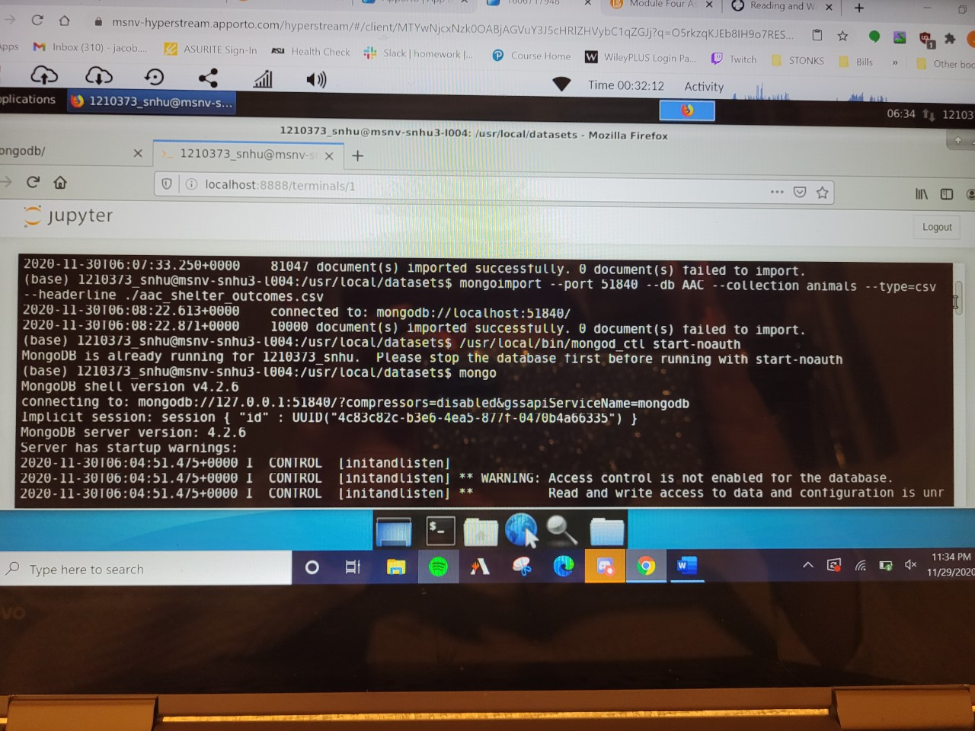

## Contact

Karla Goodwin